10-29-2012

To:
Daniel Benson
Aviation Section
Texas Department of Transportation

From:
Geo-Air Consulting
Department of Geography
Texas State University

CC.:
Dr. Yongmei Lu
Mr. Ryan Schuermann

Subject:
Dear Mr. Benson,
This report has been prepared by Geo-Air Consulting to inform and illuminate the progress and intentions of Geo-Air Consulting in regards to the San Marcos Airport Expansion project, contracted by the Texas Department of Transportation. The report will offer a brief synopsis of scope and purpose of the project, followed by a systematic examination of the three primary deliverables as described in the request for proposal. The plans for completion of these deliverables will be discussed separately to offer a concise understanding of the progress, challenges, and future tasks for each. As of 10-29-2012 the project is moving forward at a brisk pace. Some challenges have been encountered, but at the current time, most challenges have been met. The analysis for both land use and the hazards map is moving forward at a desirable pace. Geo-Air is extremely happy with the forward momentum we have attained in the past few weeks and look forward to delivering the completed project.

Purpose:
The three goals established in the project proposal continue to be the focus of this project.
- To establish a total feasible runway length for runways 13-31 and 17-35 based on the needs of the critical aircraft, the Gulfstream IV (G450).
- To provide an airport hazard zoning map of imaginary surfaces as defined by Federal Aviation Administration code 14 CFR 77, and to evaluate any possible penetrations of the surfaces based on the analysis of locally elevated objects.
- The creation of a comprehensive Controlled Compatibility Land Use map as defined by the Texas Airport Zoning Act.

Scope:
The scope of the project remains the same two-fold extent. The ground extent consists of 3 by 10 mile grids for each runway under review, as defined by Texas Airport Zoning Act regulations. These 30 square mile areas will be reviewed and classified for the Controlled Compatibility Land Use map. The scope for the airport hazards map will include 50,000 foot zones from the end of each runway as defined by the Federal Aviation Administration.

Timeline:
At the current time this project will be completed on or before the expected delivery date of December 10, 2012. Data collection was to be completed by October the 15th, 2012 according to the timeline. The data needed for the hazards zoning map and overall runway length which included remote sensing imagery and Z value data from TXDOT was obtained very early on. The other pertinent data (shapefiles from the city of San Marcos to be used for land use analysis) were obtained by October the 17th, 2012. Data analysis began on October the 8th, 2012 and has continued until the present. Analysis should be complete by the second week of November. Modeling of our data will correspond with the end of the analysis phase of the project. Geo-Air will then have the following three weeks (November 15th – December 7th) to evaluate the analysis, integrate our findings into the website, write the final report, and finish the final deliverables. Geo-Air fully expects to complete all project tasks on time.

Runway Extensions:

Work Completed
The 13-31 runway and 17-35 runway extension calculations are completed and within compliance standards for the FAA guidelines. The extensions have been made based on the planning map provided with the request for proposal. For 13-31 the extension of 800 feet has been added to the 31 end of the runway. The 17-35 runway extension has been broken up into two sections, one for each end of the runway. On the 17 end we have added 500 feet, and on the 35 end we have added 1,000 feet. This approach has been selected due to the railroad line running along the southern end of runway 17-35.

Present Work
We are currently aligning and adjusting the approach polygons to provide the necessary base for analysis and modeling as per FAA guidelines. Each imaginary surface is in the process of being adjusted to the correct elevation. The approach surfaces will be modeled from the proposed runway extensions that have been made for 13-31 and 17-35.

Future Work
By extending these approach surfaces Geo-Air will be able to provide the Texas Department of Transportation with data regarding any penetrating objects that might affect future development of these runways. Penetrations, if found, may allow the San Marcos airport to adjust approach and departure procedures for flights utilizing runways 13-31 and 17-35. These possible penetrations could provide the City of San Marcos the information necessary to adjust zoning code and work with landowners to create a safe flight approach and departure.

Imaginary Surfaces:

Work Completed
To date, calculations for the approach angles and distances are complete for the 13-31 runway. The planar view of the San Marcos Municipal Airport is complete at this time, thanks to the cooperation of the Texas Department of Transportation and Mr. Benson for the data provided. There is concern about the 17-35 runway because of the railroad location at the southern end.

Present Work
We are currently adjusting all the approach surface polygons to their proper Z values so we will be able to determine if we need to make any adjustments and/or any future calculations for the imaginary surfaces. The approach angles and distances for 17-35 are still under evaluation based on the requirements listed for railroads (height above railroad of 23 feet).

Future Work
The profile view has just been started and will be completed as quickly as possible. There has also been some degree of difficulty with the 3D rendering, but the kinks are getting worked out. This portion of the imaginary surfaces will obviously take the most time. Even though we lack some experience, we are dedicated to deliver the product as agreed upon.

Controlled Compatibility Land Use:

Work Completed:
Data collection for the controlled compatibility land use map provided a significant challenge. On October the 17th 2012, Geo-Air acquired two data files from the City of San Marcos (COSM). One file was a shapefile of parcels for San Marcos and the surrounding area. The second was a shapefile for existing land use. These files were provided by Joan Hickey, the GIS administrator for the COSM. This acquisition was indeed a breakthrough. It provided us a usable database of existing land use, and allowed us to look at our ground scope broken down by parcel boundaries. Most parcels within the COSM have been classified, but outside of the city limits, most all parcels were unclassified. This posed our biggest challenge. We tried contacting the city of Kyle and the city of Lockhart to request land use data for the area around the Airport (Caldwell County) with no success.
By October the 22nd 2012, it was clear that no existing land use files had been created for the portion of Caldwell County that surrounds the Airport. The methodology had to change. The decision made was to reclassify each parcel based on the existing land use categories provided by the COSM and then make a record for each parcel within the land use database. By working within the framework of land use classification by COSM, we hope to provide an immediate upgrade to the city’s existing land use database. The reclassification process is a mix of using the digital imagery provided by TXDOT, calling landowners of certain parcels with confusing clarity, and utilizing Google Earth as a visual aid. As of 10/29/2012, roughly 75% of these previously unclassified parcels have been reclassified for existing land use.

Present Work:
At present, the reclassification of parcels continues. Each parcel requires a visual inspection of the digital imagery. Continuation of this process should last until the first week of November. Each reclassified parcel must be added to the existing land use database. This process is quite time consuming, but there is satisfaction resulting from the progress. The expectation is to be able to continue the work until completion and provide a fleshed out database for the city.

Future Work:
Once the parcels have been reclassified and the database has been updated, the next task will be to buffer the runway centerlines. These buffers will correspond with the controlled compatibility land use areas defined in the Texas Airport Zoning Act. The runways will have a 1.5 mile buffer to each side of the runway, and this buffer will extend to 5 miles in each direction. The plan is to buffer each runway (13-31, 17-35, 8-26) and then combine these three areas to create one polygon of controlled compatibility. This defined polygon will be used to extract all reclassified parcels pertinent to the controlled compatibility land use area. Modeling and mapping of this area will follow.

Conclusion:

In summary, Geo-Air is very pleased with the progress of the project. We feel that each of the three primary goals of this project is moving forward at a pace consistent with the timeline. Unless proven unsuitable during penetration analysis, the runway extensions should be in line with the requested overall lengths described in the planning map provided in the request for proposal. Because of the proximity of nearby Reedsville and the railroad, the team may want to schedule a visit to the airport to gauge these obstructions from a ground view. The modeling of the imaginary surfaces continues, with 13-31 almost complete and with 17-35 in processing. The elevation of these surfaces will soon follow. The reclassification of existing land use continues, and when complete, should provide the COSM with a seamless database which adheres to existing standards employed by the city. Geo-Air is confident. The project moves forward, and by November the 15th, 2012 we plan to start working on the final deliverables.

Supplemental Imagery:

Map 1: Runway 31 (800 foot) extension with imaginary surface.
Runway 35 (1,000 foot) extension with imaginary surface.
Map 2: Runway 17 (500 foot) extension with imaginary surface.
Map 3: Existing Land Use at San Marcos Airport

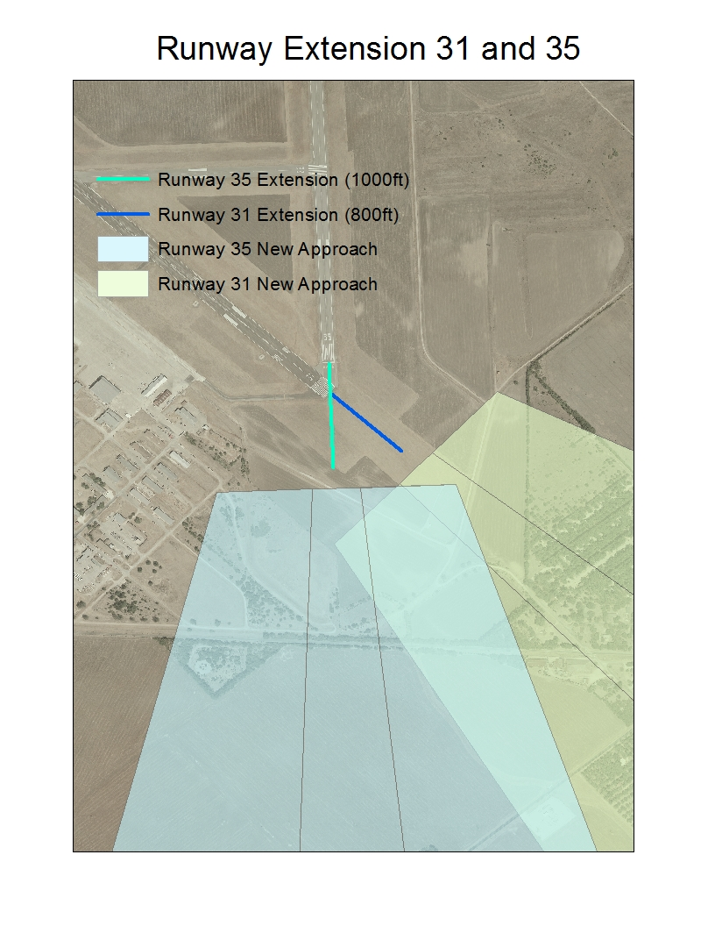
Image 1

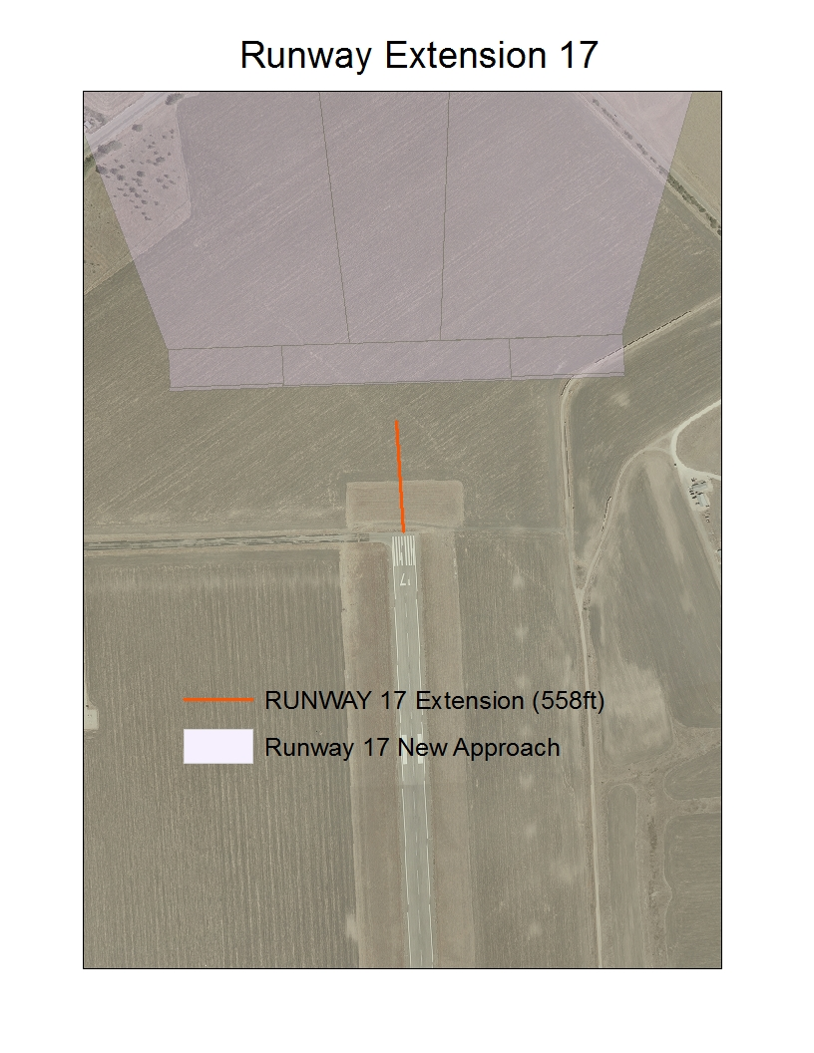
Image 2
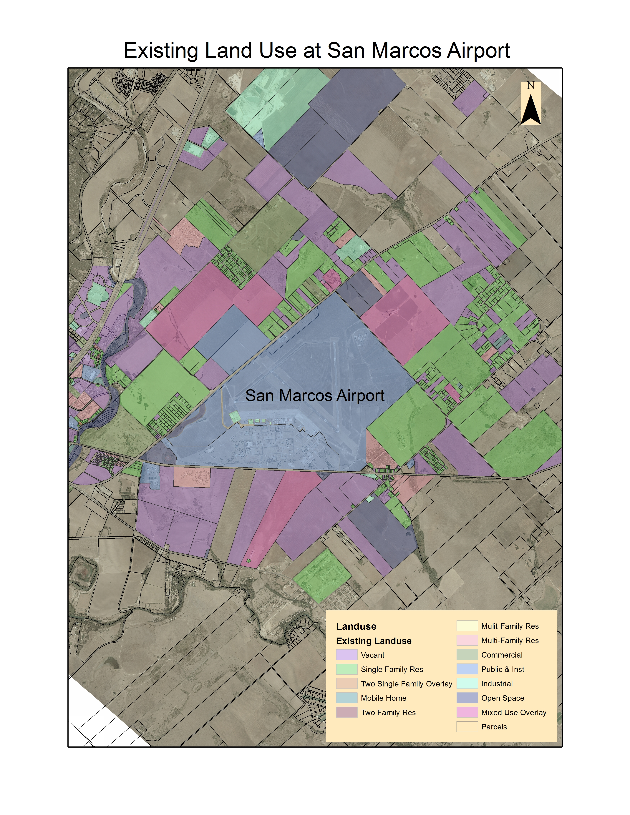
Image 3

